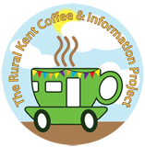
A New Pop-up Café
coming to HARVEL!
Venue: Village Hall Car Park
Thursday 17th August
Thursday 14th September
Thursday 12th October
10.30 am – 12.30 pm

Come and get together with old friends and new and have a free (donations welcome!) cuppa and a delicious slice of cake. We’ll have all sorts of local information on board or you can just come for a chat.
Please help us to spread the word. Everyone welcome ... see you soon!
